Home Exercise Guide - Arduino Uno R3 + Sidekick Basic Kit V2

**Objective.** Gain hands‑on experience in basic electronics, rapid prototyping, and embedded programming while working entirely from home. By the end you will be able to:

* identify and wire common electronic components
* write and debug simple Arduino sketches that use digital, analog, PWM and servo interfaces
* design and document small electronic systems (schematic + block diagram)
* create and present a mini‑project that extends the supplied tutorial tasks

# Getting Started

1. **Install the Arduino IDE** and connect the Uno R3. Verify that File → Examples → 01.Basics → Blink uploads and blinks the on‑board LED.
2. **Open the Sidekick online tutorial** (<https://wiki.seeedstudio.com/Sidekick_Basic_Kit_for_Arduino_V2/> or the local mirror)
3. **Prepare your workspace** – Breadboard on a non‑conductive surface, parts in the labelled tray, USB cable within comfortable reach.

**Safety check** – Never power the board if you feel components getting hot; immediately disconnect USB and re‑check wiring.

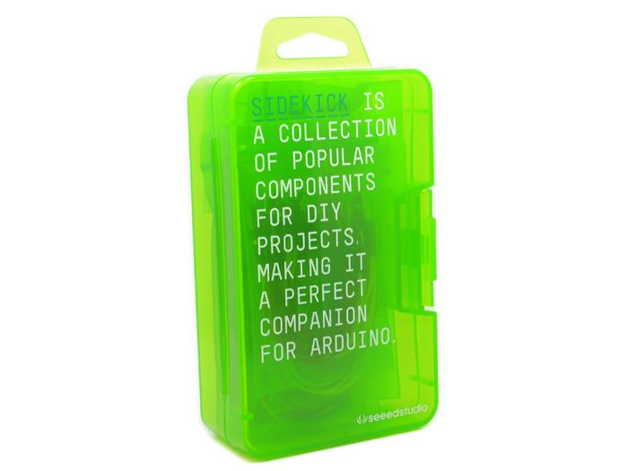

Figure : Sidekick Basic Kit for Arduino V2 <https://wiki.seeedstudio.com/Sidekick_Basic_Kit_for_Arduino_V2/>

**For the Lab report:**

# Sidekick Tutorial Documentation

1. **Block Diagrams** – Provide a *high‑level* code flowchart or state‑diagram for **three** tutorial tasks (e.g. *push‑button control*, *analog potentiometer input*, *mini‑servo sweep*).
2. **Electronic Schematics** – Neat, labelled schematics for the same three tasks. Use any CAD tool: KiCad, EasyEDA, Fusion360, Altium etc.
3. **Discussion** – ½ page reflecting on difficulties and debugging strategies.

# Mini Project

Design and build a small application using the Sidekick components plus any optional parts from the lab junk‑box.

**Deliverables**

* Full electronic schematic
* Block diagram of the firmware logic

- 3‑D design (STL or drawing) for an enclosure and/or mechanical adapters

- 200-300 word application description (purpose, key features, future improvements)

**Demo** – Be prepared to present the working project to the instructor during the last lab sessions (3–5 min + Q&A).

**Mini Project Inspiration:**

* **Arduino game‑pad** – build a handheld controller for the Alvik robot (joystick + buttons transmitting over serial with python over Wi-Fi implementation or Bluetooth).
* **Light‑tracking servo** – closed‑loop sun tracker to maximize solar‑panel illumination.
* **Sound detector** – clap sensor that triggers a buzzer or LED flash.
* **Ambient mood light** – RGB LED that changes color with room brightness or temperature.
* **Tiny desk fan** – potentiometer controls motor speed; optional temperature feedback.

You are encouraged to propose *any* idea that can be realised safely with the available parts.

Good luck, and remember: **systematic wiring checks + incremental code testing** will save you hours of frustration!